Post Prototype

Introduction:

In this section of the project I will describe what feedback I have received from my client and then display the changes to my project from any ideas that I have put on board. Moreover, I will explain how these changes have affected the system as well as how they’ve impacted how the system is used by both members and staff.

Feedback from staff and prospective customers:

I presented my prototype to the staff members and some volunteering customers from Mongoose Games. After having them test it, I was given some valued feedback about my system. The customers told me that they liked the account creation screen, and that it was very intuitive and asked appropriate personal details from them (which complies with GDPR rules), yet they demanded that a feature were implemented for them to be able to view/update their details to ensure accuracy of their details, they also wanted a feature to view their purchase history, as well as being able to add games to their wishlist and be notified when the game gets in stock. In addition, the staff members were ecstatic with the system and were impressed with the variety of important functions that I managed to prototype successfully for them. For example the Game Search function which they particularly enjoyed as in comparison to the paper based system, where they would have to flick through all of the pages in the notepads to find a certain game, they just need to know the title and all relevant details are shown to them. However, they made it clear that I needed to add a “return to main menu” button on each function for when they would want to carry out various tasks in one instance of the program without having to restart every time which would be inconvenient and time consuming. They also wanted to make the system more professional and time efficient, that during tasks such as adding a game or calculating a buying price for a game that they would be a “Clear” button which would clear all of the fields so they wouldn’t have to manually clear the fields to populate them again. The staff members also expressed their opinion on how the customers shouldn’t have access to the “quote calculator” for games as they might get inaccurate results, instead they should send a request to the staff members to calculate a quote for their game, and then be sent their quote back to them to let them know exactly how much they’ll get.

I will accept the idea of the “View my details” form that the prospective end users have suggested as I believe this is important in allowing customers to verify data accuracy and to subsequently edit their credentials, but not any other details such as address or phone number as I believe this should be sent in request from to a staff member. Moreover, I will not be adding a purchase history as suggested by the customers as I believe this feature is fairly useless and has no true need - it would take significant time from the overall developing process that is better spent on other features. They will be able to add games to their wishlist and notified when it gets in stock (as suggested) through sending a request and a staff member letting them know when their game comes in stock, this is important as it promotes customers returning to the store to check if their desired game is in stock, possibly buying other games on their trips. I will also be adhering to the advice given by the staff members, that a “Return to main menu” button should be added to each form. I believe this is very important as it enables staff members and customers alike to carry out many tasks in one instance of the program. I will also be removing the customer’s access to the “Quote calculator” as per staff request as it could be misleading if they were to get a quote using their bias opinion (want highest price possible) and could lead to a quarrel when a staff gives them their actual quote.

The implications of all of this feedback are that more caution will have to be taken while programming the software to ensure that the needs of both staff and customers are met, as well as legal needs e.g. GDPR. Moreover, it will mean that more functionalities are added for customers, as demanded which might be difficult to achieve due to time constraints. In addition, the feedback received also implies that I should be more prudent in my approach, ensuring that customers should not have access to certain features e.g. quote calculator as made clear by staff members.

Feedback from competent third parties:

* I interviewed some colleagues and asked them questions about how they would feel about using the current system for a normal 9-5 working day which is what the staff members at Mongoose Games will end up doing. this made them think of ideas that would speed up processes or allow more detail to be obtained to facilitate transactions. After showing and discussing the prototype with them this is the feedback they gave me:
* My first colleague told me that both staff members and customers should have a limit as to how many times they can attempt to login, which will be viewed by them receiving a message after every login attempt, informing them of how many attempts they have and how many attempts they have made. After 3 attempts, the system will close itself.
* The second colleague then requested to me that more information should be stored on customers such as DOB, town and postcode to be able to differentiate customers with more ease and have more detail on where they reside.
* The first colleague them suggested to me, prior to reviewing the prototype, that in the Buying price calculator, the fields Popularity and Condition of the case should be populated using numeric up down boxes to reduce human error which would give a wrong, more expensive price which could cause the business to lose money.

I will be accepting the idea of the first colleague, to present how many attempts a customer/staff member has via an error message rather than via an “Attempts” textbox as it will aid the user in noticing that their login attempts are limited which is an essential user friendly feature. I will partially accept the idea from the second colleague, I will add a town and postcode but not date of birth as I believe that that piece of data is unnecessary and could produce discomfort for a customer who is sensitive about their age. This will be respected. Moreover, I will be accepting the second idea of the first colleague referring to the addition of numeric up down boxes to replace text boxes in the “Buying price calculator” form as it will definitely aid the staff member to keep within the desired boundaries for data entry as well as facilitating their input as a keyboard won’t be necessary.

The implications of these feedback are that I will have to ensure that outputs are made more clear to customers, highlighting errors and desired courses of action e.g. displaying login attempts - taking into consideration that not everyone using the system will be computer-literate and that intuitivity and user-friendliness should be prioritised. Moreover, the feedback implies that more data from customers need to be stored e.g. Town, Postcode, which could prove troublesome as storage space could be limited as well as customers could feel uncomfortable with giving certain parts of data. Finally, the fact that the use of drop down boxes has been indicated to me by a colleague leads me to understand further the importance of ensuring the ease of data input which could prove arduous to implement in every form of the project.

Before changes

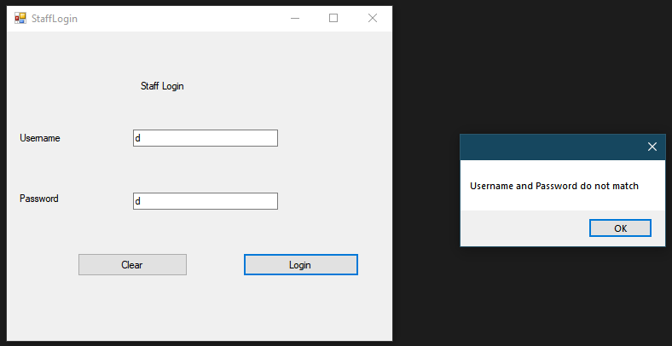

After changes

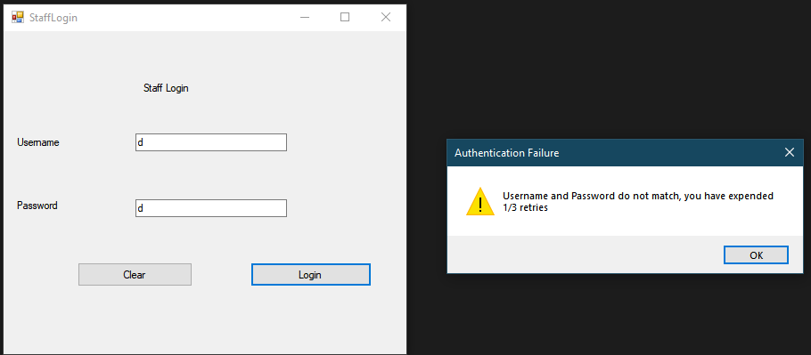

This is a screenshot of invalid credentials being inputted into the system before and after adding the 3 try limit. Every time they attempt to log in but fail, they are notified of this, as well as how many retries they have left. Once they surpass 3 attempts, the system will shut itself down to prevent further login attempts from being made. This is something that my client made very clear to me that he wanted during our interview as it prevents against brute force attacks from hackers in an attempt to gain access to the system which they could then access personal customer details and use them maliciously. I have chosen to include it into the messagebox instead of using a textbox as it gets the user’s attention more and they’re more likely to realise the presence of the 3 attempt limit.

Before changes

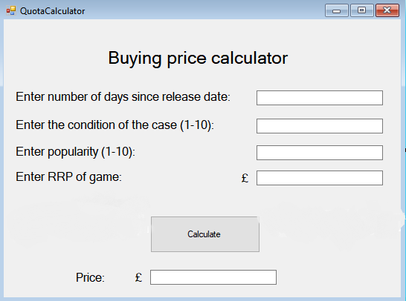

After changes

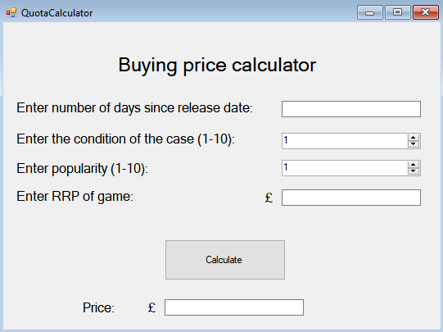

This is the screen of the Buying price calculator that staff use to calculate a quote they should give the customers for a game. As it can be seen, I have changed the text boxes that I used for the condition and popularity of the game into Numeric up and down boxes. I did this in order to implement a form of erroneous data entry prevention which could potentially affect the profitability of the business if it were to be entered. It also helps the staff member keep into the set boundaries (1-10) of the category and could be quicker to enter in some instances as the keyboard won’t have to be used.

Before

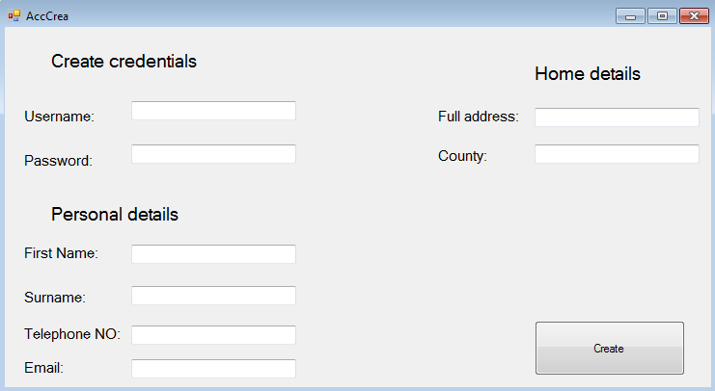

After

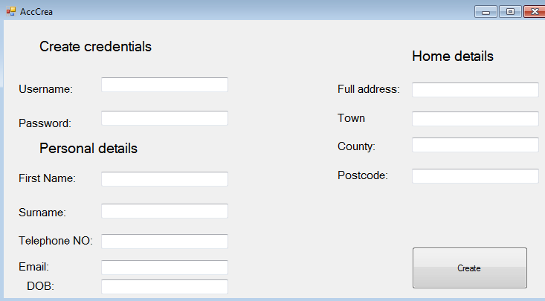

After the changes to the account creation form, I have added fields to the customer file to store their date of birth, their town and postcode to be able to differentiate customers with more ease and have further information on where they reside for general purposes. It could also help us identify trends in our customer base by data such as age and their consequent spending habits, which could help us better tailor our stock.

Refinement of design interfaces

Original

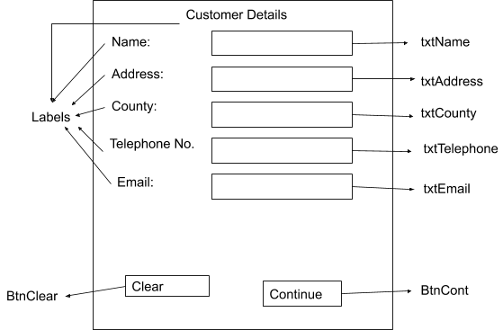

Refined

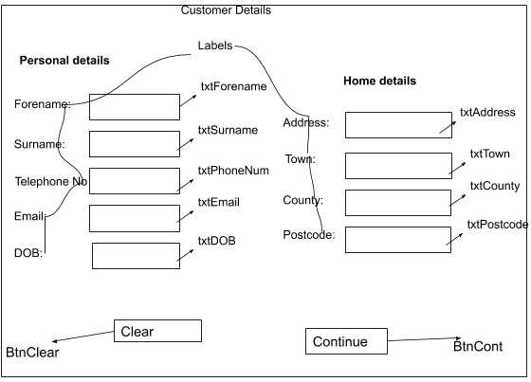

I have refined the design interface for the customer details, adding all of the new requirements for the customer (as demanded by the client) to enter along with a more intuitive structure.

Original

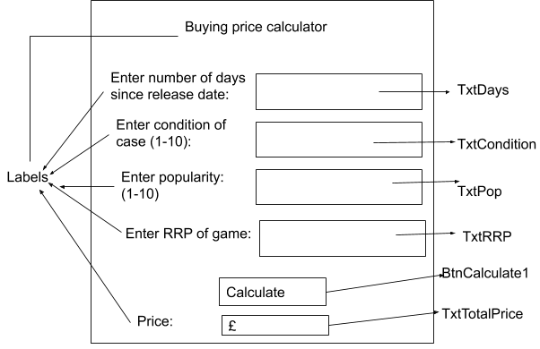

Refined



I have refined the design interface for the buying price calculator, taking into account the NumericUpDown boxes that I have chosen to implement for the condition and popularity in replacement for text boxes which will facilitate data input as well as ensuring its validity.